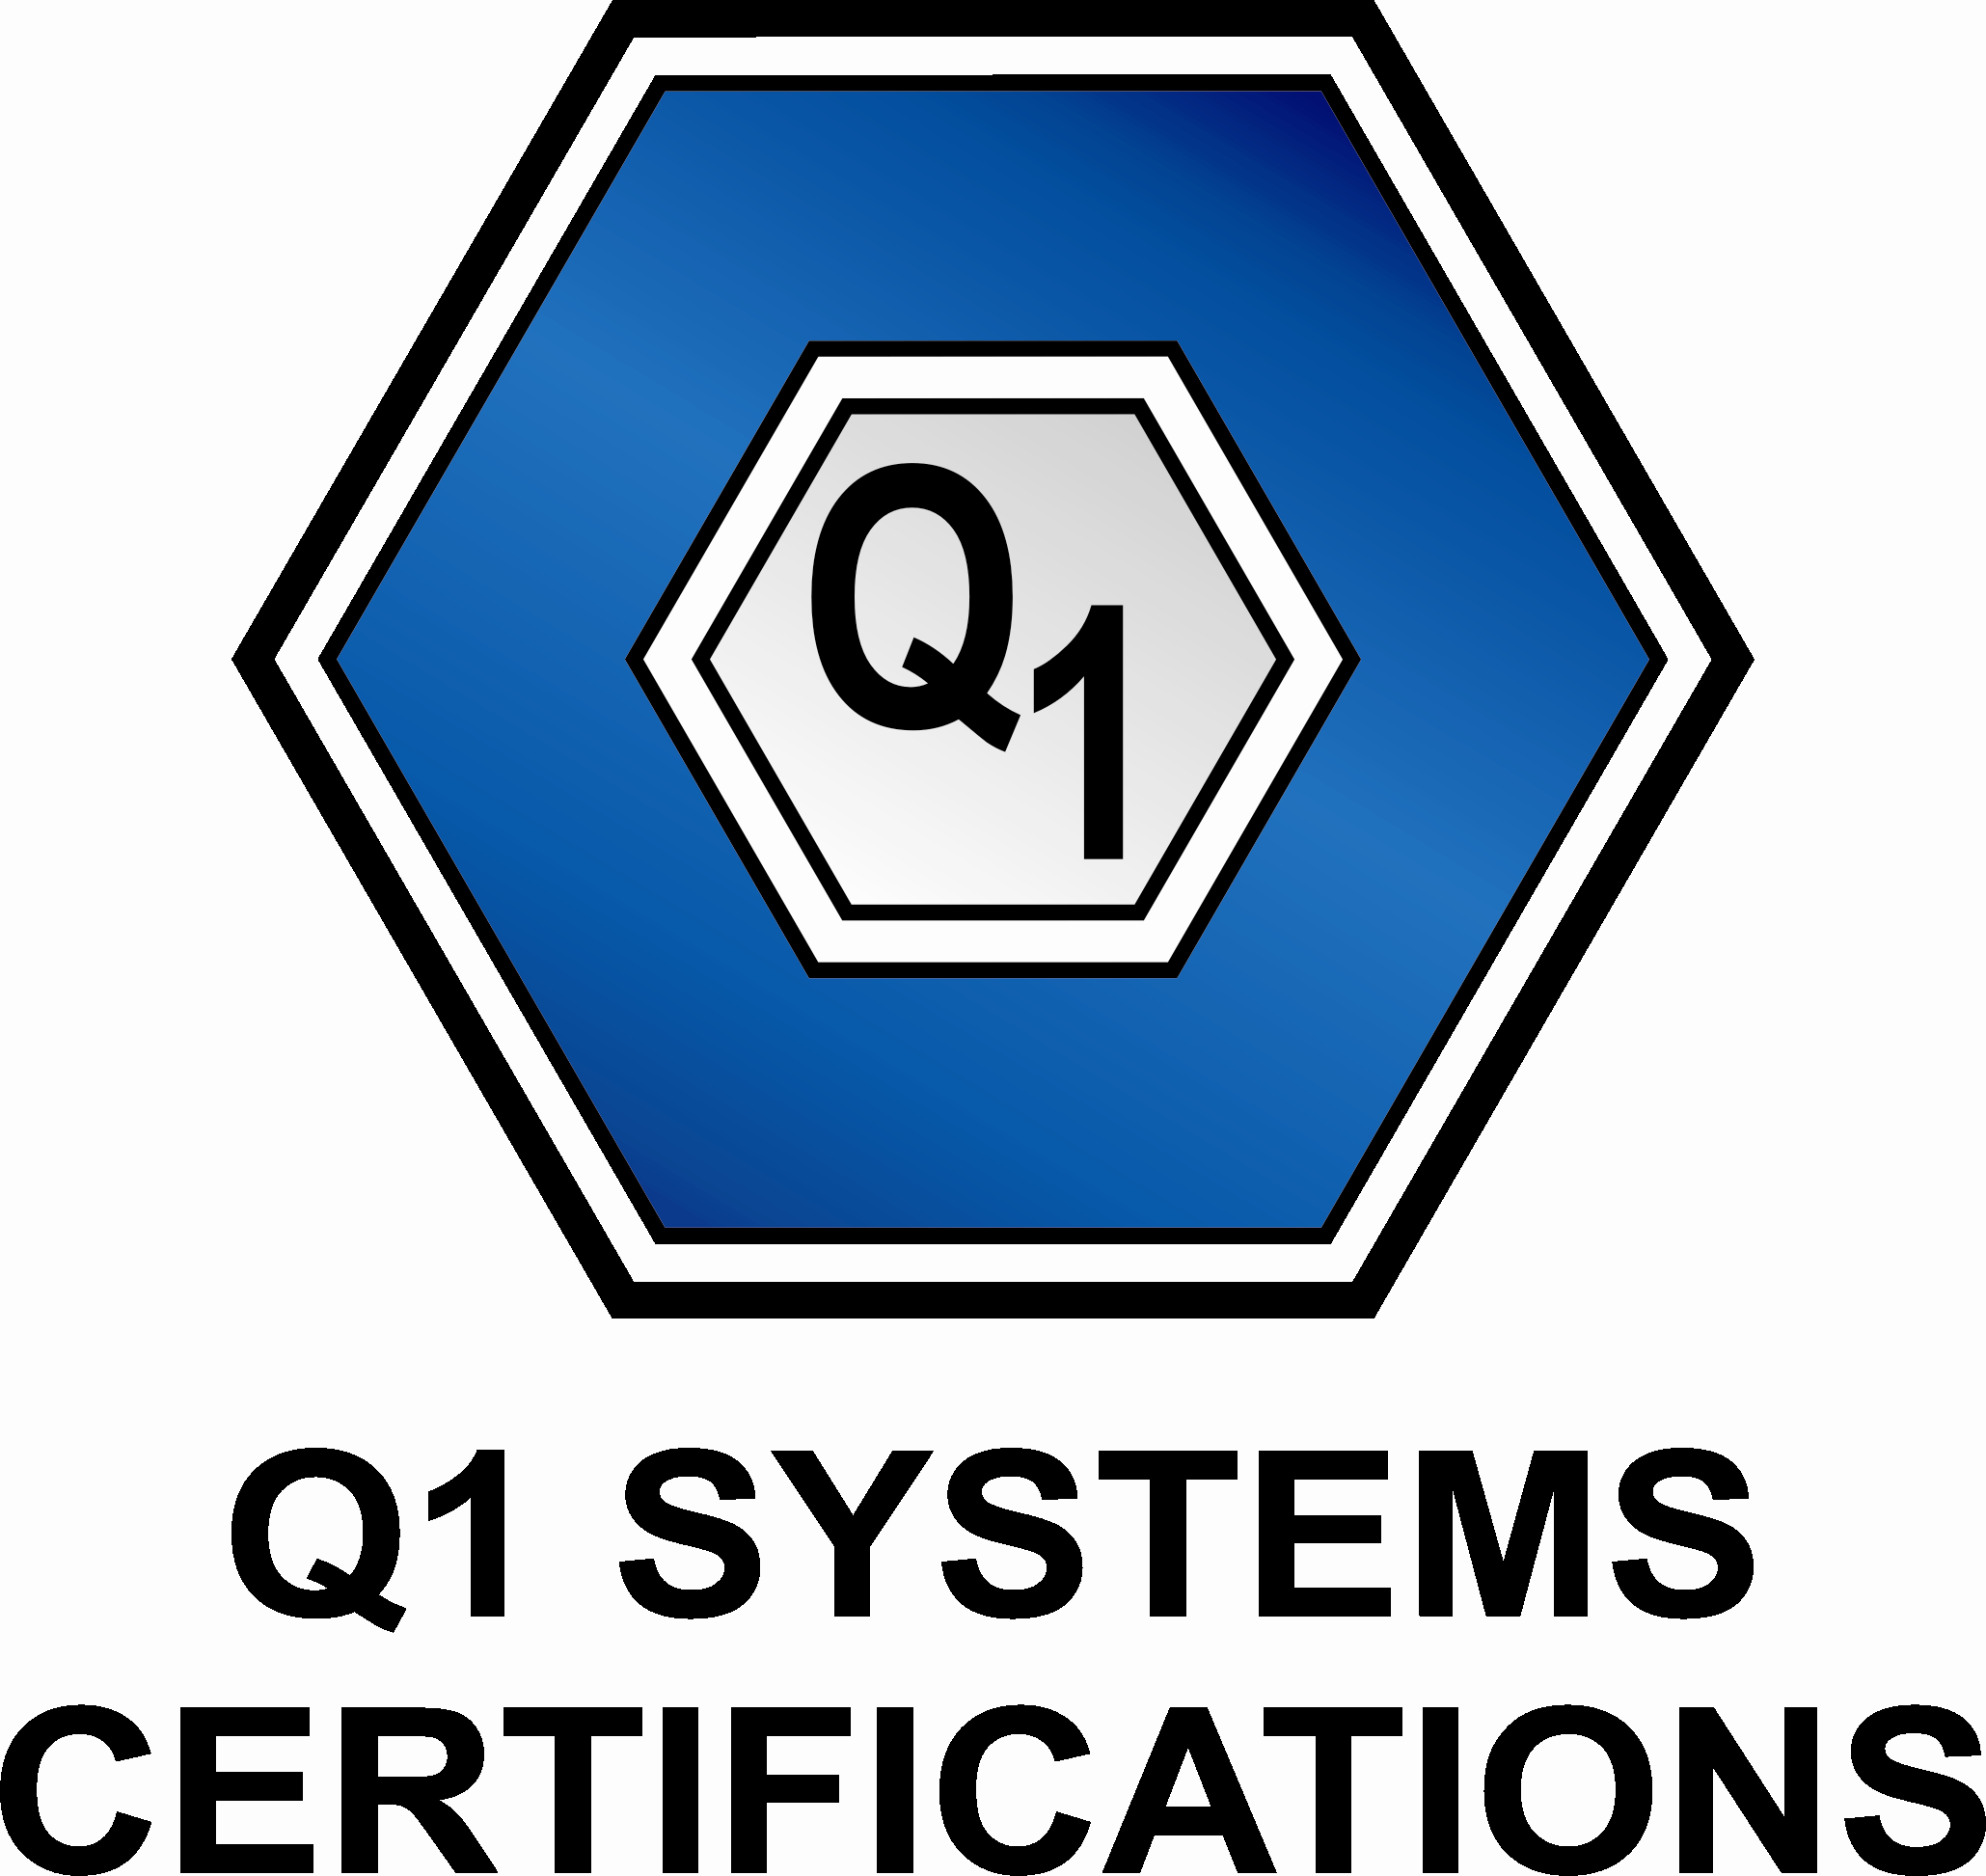
Q1 Systems Certifications Private Limited

APPLICATION FOR CERTIFICATION
□ Initial Certification □ Re-certification Transfer Certification

Organization Name |  |  |  |  |  |  |  |  |  |  |  | Prop. / Partner/ Director/ MD
Address(s)*

Address(s)* |  | TEL |  |  |  |  |  |  |  |  |  |  |  |  |  |  |  | E-mail
Address(s)* |  | MOB |  |  |  |  |  |  |  |  |  |  |  |  |  |  |  | Fax
No. of Sites |  |  |  |  |  |  | Site Address |  |  |  | Site 1
 |  |  |  |  |  |  |  |  |  |  | Site 2
Management Representative
Standard |  | 9001 |  |  | 14001 |  |  |  | 18001 |  |  |  | 22001 |  |  |  |  |  | 27001 |  |  |  | Others
Desired Scope of Certification*
Detail Stage Wise Activities Involved In Your Business Process Including Support Process / Departments
Outsourced processes
No. of Shifts |  |  |  |  |  |  |  |  |  |  |  | Shift Timing
Number of Employees* |  | Office |  |  |  |  |  |  |  | Site 1 |  |  |  |  |  |  |  |  |  | Site 2
 |  | Permanent |  |  |  | Contractor |  |  |  | Permanent |  |  |  | Contractor |  |  |  |  |  | Permanent |  |  |  | Contractor
Products and/or Services
Legal Obligations If Any
Date of Implementation |  |  |  |  |  |  | Have You Completed Internal Audit |  |  |  |  |  |  | Yes | No |  |  | Have You Completed Management Review Meeting |  |  |  |  |  |  |  | Yes | No
Consultancy Organization and/ or Consultant |  |  |  |  |  |  |  |  |  |  |  |  |  |  |  |  |  | □ Self Prepared
Current Certification (Transfer Only) |  | Certification Body (Attach certificate) |  |  |  |  |  |  |  |  |  |  |  |  |  | Latest Audit  (Attach report)
Other information

Name / Designation ____________________ (Signature)

Date: Company Seal

